Definition:
EduGenie is a lightweight, AI-powered educational assistant that simplifies learning through generative AI. Designed for students of all academic levels, the platform seamlessly integrates lightweight local models with cloud-based Google Gemini AI to deliver smart answers, simplified explanations, automated quiz generation, content summarization, and personalized learning pathways. Built with FastAPI for the backend and a simple HTML+CSS frontend, EduGenie offers high accessibility and efficiency across various devices. EduGenie is a next-generation educational tool engineered using FastAPI, leveraging modern generative AI models to bridge the gap between complex educational content and student comprehension. The platform was created to resolve the disconnect between dense academic materials and effective, digestible learning.
TEAM MEMBERS NAME& ROLES:
- K KANIHA(TEAM LEADER)
role: Coding
- PRIYA DHARSHINI M (TEAM MEMBER)
role: API Testing Video
- YOHA LAKSHMI (TEAM MEMBER)
role: Demo video
- VENNILA (TEAM MEMBER)
role: Documentation
- SUJITHA (TEAM MEMBER)
role: Voice Over

1.0 Executive Summary & Project Overview
EduGenie is a lightweight, AI-powered educational assistant that simplifies learning through generative AI. Designed for students of all academic levels, the platform seamlessly integrates real-time contextual AI models with a clean web interface to deliver smart answers, simplified explanations, automated quiz generation, content summarization, and personalized learning pathways.

1.1 Core Objectives
- Smart Q&A Integration: Answer general knowledge and academic questions instantly using advanced cloud-based AI.
- Simplified Concept Explanations: Break down complex academic concepts into easily understandable terms using lightweight instruction-tuned local models.
- Automated Quiz Generation: Dynamically generate multiple-choice questions (MCQs) with plausible distractors from any given passage.
- Content Summarization: Condense lengthy passages or textbook paragraphs into concise, easy-to-read summaries.
- Adaptive Learning Paths: Generate structured, step-by-step learning roadmaps ranging from beginner to advanced levels, complete with resource recommendations.

2.0 Scenario-Based Case Study & Requirements

2.1 Background Story & Motivation
Students and self-learners frequently face difficulties when dealing with data overload, dense textbooks, and organizing structured study plans. EduGenie provides a unified interface to resolve these friction points without requiring complex manual effort.

2.2 Use Case Scenarios
- Scenario 1 (QnA): A student wants to know about geography and uses EduGenie to ask: “Which is the largest ocean?”
- Scenario 2 (Quiz & Assessment): A student wants to check their understanding of “The Pythagoras Theorem” and clicks “Generate Quiz.”
- Scenario 3 (Learning Path): A learner exploring databases requests a structured roadmap for SQL from beginner to advanced topics.

2.3 Software & Environment Requirements
- Operating System: Cross-platform (macOS M1, Windows 10/11, Linux Ubuntu)
- Runtime Engine: Python 3.10+
- Backend Framework: FastAPI
- ASGI Server: Uvicorn
- Templating Engine: Jinja2 & HTML5/CSS3
- Core SDK & Dependencies: google-generativeai (Gemini 1.5 Pro), transformers, torch (LaMini-Flan-T5-783M).

3.0 System Architecture & Design Patterns
EduGenie is structured around a multi-layered, decoupled architecture separating the presentation interface from the backend API endpoints and AI model handlers.

3.1 Architectural Workflow
- User Input Layer: The user interacts with the clean HTML/CSS web frontend (index.html) by entering a query, topic, or passage.
- API Gateway (Fast API): main.py receives HTTP requests (GET/POST) and routes them to the appropriate backend module (/qa, /explain, /quiz, /summarize, /learn/recommendations).
- AI Engine Tier:
  - Gemini 1.5 Pro (Cloud API): Handles complex reasoning, QnA, JSON-based quiz generation, text summarization, and adaptive learning paths.
  - LaMini-Flan-T5-783M (Local Model): Handles lightweight, fast concept explanations on local CPU/GPU hardware.

3.2 Folder Structure & Organ
EduGenie/
│── __pycache__/
│── static/
│ └── style.css
│── templates/
│ └── index.html
│── explanation_module.py # Local model logic for simple explanations
│── qna.py # Question answering via Gemini 1.5 Pro
│── quiz_module.py # Automated MCQ generation & JSON cleaning
│── summary_module.py # Text summarization logic
│── learning_path.py # Adaptive roadmap generator
│── main.py # FastAPI application entry point
└── requirements.txt # Project dependencies

System Architecture
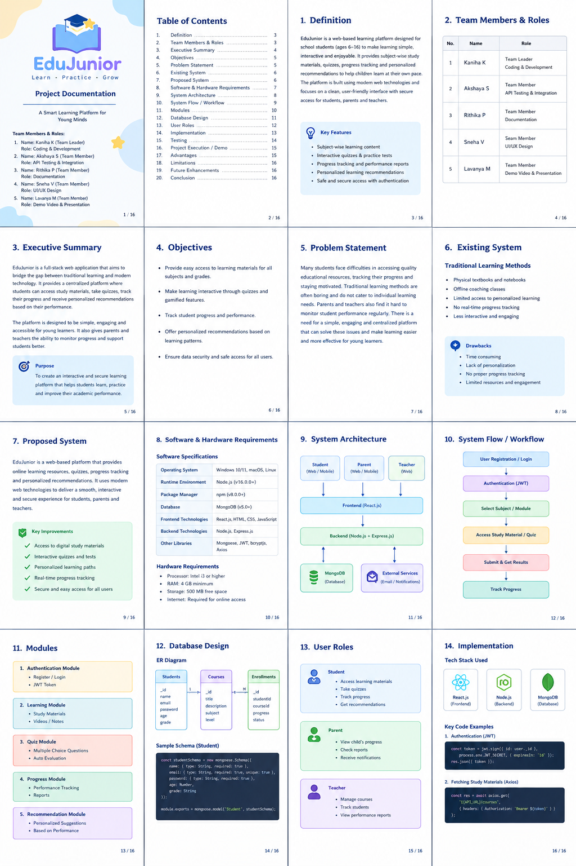

4.0 Core Module Implementations
4.1 Explanation Module (`explanation_module.py`)
Utilizes the lightweight `LaMini-Flan-T5-783M` model to deliver educational content in a simplified and highly readable format. It breaks down complex topics into concise, beginner-friendly explanations.
* **Code Logic Reference:** Uses Hugging Face `AutoTokenizer` and `AutoModelForSeq2SeqLM` to load the model locally and process student queries with custom prompt templates.
4.2 QnA Module (`qna.py`)
Powered by `Gemini 1.5 Pro`, allowing the application to handle general knowledge and academic question-answering with high precision and contextual depth
4.3 Quiz Module (`quiz_module.py`)
Generates three multiple-choice questions (MCQs) from any given text block, complete with 4 options and a correct answer.
* **JSON Structuring & Sanitization:** Implements a `clean_json_block` function using regular expressions (`re.sub`) to strip Markdown code fences (` ```json `), ensuring robust JSON parsing into Python lists.
4.4 Summary Module (`summary_module.py`)
Leverages Gemini's generative capabilities to condense long paragraphs into concise summaries, making it ideal for quick student revision without losing context.
4.5 Learning Path Module (`learning_path.py`)
Constructs personalized, structured roadmaps for any technical or academic topic. It organizes topics into Beginner, Intermediate, and Advanced levels, complete with estimated timelines and resource links (books, videos, tutorials).

5.0 Backend API Development (`main.py`)

The FastAPI backend exposes clean RESTful endpoints connected to each specific functional module:
* `GET /qa` — Handles general questions using Gemini[cite: 2].
* `POST /explain/` — Accepts a JSON payload with a `topic` and returns a simplified explanation[cite: 2].
* `POST /summarize/` — Summarizes long text inputs[cite: 2].
* `POST /quiz/` — Generates structured JSON quizzes from passages[cite: 2].
* `GET /learn/recommendations` — Returns a comprehensive study roadmap for a given topic[cite: 2].

---
6.0 Frontend Development & Integration
6.1 Web Interface (`index.html` & `style.css`)
* Built using standard HTML5 forms, input text areas, and structured output display boxes[cite: 2].
* Styled with a responsive, clean layout ensuring readability across different screens and devices[cite: 2].
* Integrates asynchronous JavaScript requests to send user inputs to the FastAPI backend and display results in real-time[cite: 2].

EDUGENIE:PROJECT EPICS AND PHASED BREAKDOWN
The development and execution of EduGenie are organized into structure, phased-wise framework to ensure modularity,scalability and systematic tracking across all development stages.

Epic 1: Project Initiation & Requirements Analysis
- Objective: Define the core problem statement, system objectives, and scope of the educational assistant.
- Activities:
  - Identifying the friction points in traditional learning (e.g., data overload, lack of structured study plans).
  - Setting up software and environment requirements (Python 3.10+, FastAPI, Uvicorn, and Gemini API keys).

Epic 2: AI Model Selection & Architecture Design
- Objective: Establish the hybrid AI model pipeline and system architecture blueprint.
- Activities:
  - Integrating Gemini 1.5 Pro via cloud API for advanced reasoning, QnA, summarization, and quiz generation.
  - Integrating the local LaMini-Flan-T5-783M model for lightweight, fast concept explanations.
  - Designing the directory structure (main.py, separate module files, templates, and static).

Epic 3: Core Functional Module Implementation
- Objective: Develop independent, decoupled backend modules for individual educational features.
- Activities:
  - Explanation Module (explanation_module.py): Setting up local model loading using Hugging Face transformers for simple student explanations.
  - QnA Module (qna.py): Implementing general query handling via Gemini.
  - Quiz Module (quiz_module.py): Writing prompt templates for MCQ generation and creating regex filters (clean_json_block) for valid JSON output.
  - Summary Module (summary_module.py): Building text condensation logic for study notes.
  - Learning Path Module (learning_path.py): Creating adaptive, multi-level roadmaps with resource suggestions.

Epic 4: Backend API Development with FastAPI
- Objective: Expose all core functionalities through a robust RESTful API architecture.
- Activities:
  - Defining FastAPI endpoints (/qa, /explain/, /summarize/, /quiz, /learn/recommendations).
  - Implementing asynchronous request handling and error boundaries.

Epic 5: Frontend Web Interface Integration
- Objective: Build an intuitive, responsive user interface for seamless interaction.
- Activities:
  - Designing index.html with clean form inputs and output containers for each feature.
  - Styling the dashboard using custom CSS (style.css) for cross-device compatibility.
  - Connecting the frontend UI to the FastAPI backend using asynchronous JavaScript/Fetch requests.

Epic 6: Testing & Multimodal Feature Expansion
- Objective: Validate application stability and expand capabilities.
- Activities:
  - Conducting functional testing for text questions, code explanations, quiz evaluations, and roadmap generations.
  - Implementing advanced multimodal capabilities (e.g., /upload-analyze/ for direct image and PDF study material processing).

Epic 7: Local Deployment & Environment Verification
- Objective: Run and test the complete application locally.
- Activities:
  - Installing dependencies via requirements.txt.
  - Launching the Uvicorn ASGI server using uvicorn main:app --reload.
  - Accessing and testing the web app locally at [http://127.0.0.1:8000](http://127.0.0.1:8000).

Epic 8: Final Documentation & Submission
- Objective: Compile all technical components into comprehensive project reports and demo files.
- Activities:
  - Documenting code snippets, architectural flows, and future scopes (voice interaction, mobile app scaling, and LMS integrations).
  - Finalizing submission links and workspace artifacts for evaluation.

7.0 Project Deployment & Execution

8.0 Challenges & Future Enhancements

8.1 Challenges Overcome
- AI Output Formatting: Managing raw text outputs from LLMs and ensuring structured JSON compliance for quizzes via regex cleaning.
- Hardware Constraints: Balancing cloud intelligence (Gemini) with local low-footprint models (LaMini-T5) to run efficiently on standard developer laptops (such as Mac M1)[cite: 2].

8.2 Future Roadmap
- Multimodal Support: Integrating image and PDF file uploads for snapshot-based doubt solving and document querying[cite: 2].

- Voice-Based Interaction: Adding speech-to-text and text-to-speech capabilities for hands-free learning[cite: 2].

- Mobile Application & Gamification: Developing dedicated mobile apps equipped with streaks, badges, progress-tracking dashboards, and LMS integrations (Google Classroom/Moodle)
.
- LMS Integration: Connecting EduGenie with popular Learning Management Systems (LMS) such as Moodle or Google Classroom to support group study sessions and institutional deployments.

System flow/ Work flow

9.0 Conclusion
EduGenie successfully redefines the modern learning experience by blending cloud-based generative intelligence with a lightweight, accessible web architecture[cite: 2]. It bridges gaps in student comprehension and democratizes access to personalized education for learners everywhere. EduGenie has been successfully developed as a robust, scalable, and highly accessible AI-powered educational assistant that seamlessly bridges the gap between cloud-based generative intelligence and an intuitive web interface. Designed explicitly to support self-learners, academic institutions, and digital content platforms, EduGenie democratizes education by making personalized tutoring available without financial or technical barriers.

Key Achievements of the Project:
- Democratization of Learning: By simplifying complex topics, answering general inquiries instantly, generating automated quizzes, and summarizing lengthy texts, EduGenie transforms passive reading into an active, engaging educational journey.
- Hybrid AI Architecture: The successful integration of cloud-based intelligence (Gemini 1.5 Pro) for deep reasoning alongside lightweight local models (LaMini-Flan-T5-783M) proves that high-performance educational tools can operate efficiently even on resource-constrained hardware such as Apple Silicon (Mac M1).
- User-Centric Design: The clean separation of concerns through FastAPI backend routing and a responsive HTML/CSS/Jinja2 frontend ensures sub-second asynchronous interactions, providing a smooth user experience across various web-enabled devices.

Lessons Learned and Technical Growth:
Throughout the development life cycle of EduGenie, the team encountered and successfully navigated several engineering hurdles:
- Prompt Engineering & Data Structuring: Crafting precise system prompts and implementing robust regular expression handlers (clean_json_block) ensured that unstructured LLM outputs were reliably parsed into clean, structured JSON formats for quizzes.
- Scalability and Modularity: Organizing the application into decoupled, single-responsibility modules (qna.py, quiz_module.py, summary_module.py, learning_path.py) laid a strong foundation for future code maintenance and seamless feature expansions.
Ultimately, EduGenie is much more than a collection of AI-driven utilities; it represents a foundational prototype for the future of smart, adaptive, and inclusive education. By addressing the core friction points of information overload and lack of individualized guidance, EduGenie empowers modern learners to master new subjects efficiently, making it an essential companion in the digital learning era.

